**How to Mount Azure Storage File Share on a Windows Server**

**Step 1:** Create a Virtual Machine (VM)

* Log in to the Azure portal.
* Navigate to Virtual Machines -> Create a virtual machine.
* Configure and Complete the setup and create the VM

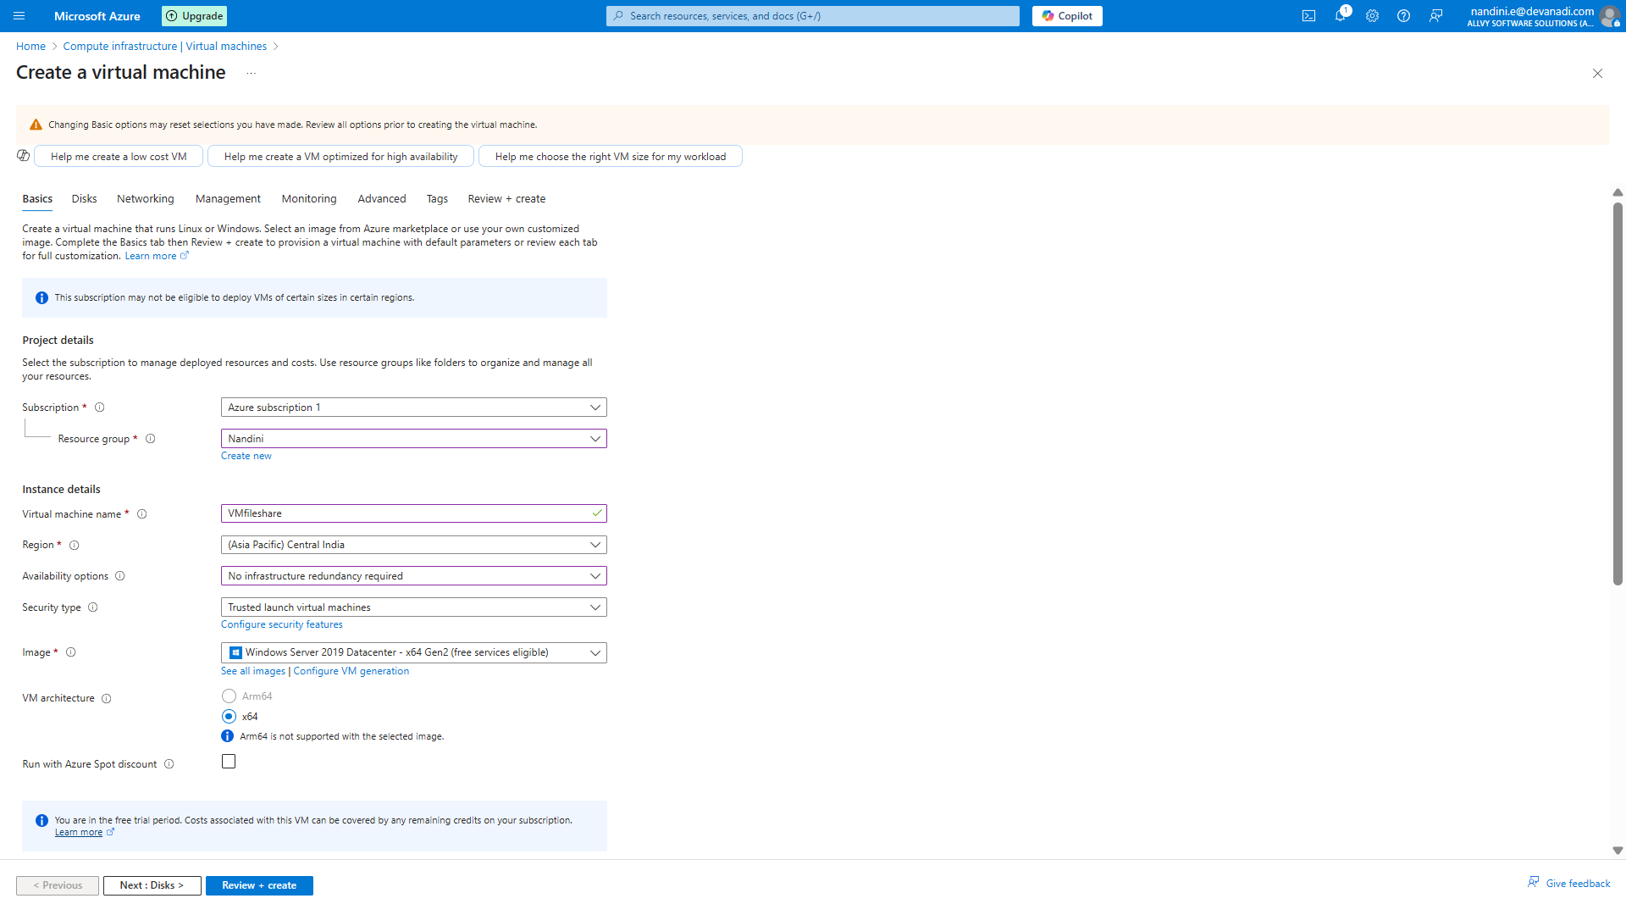

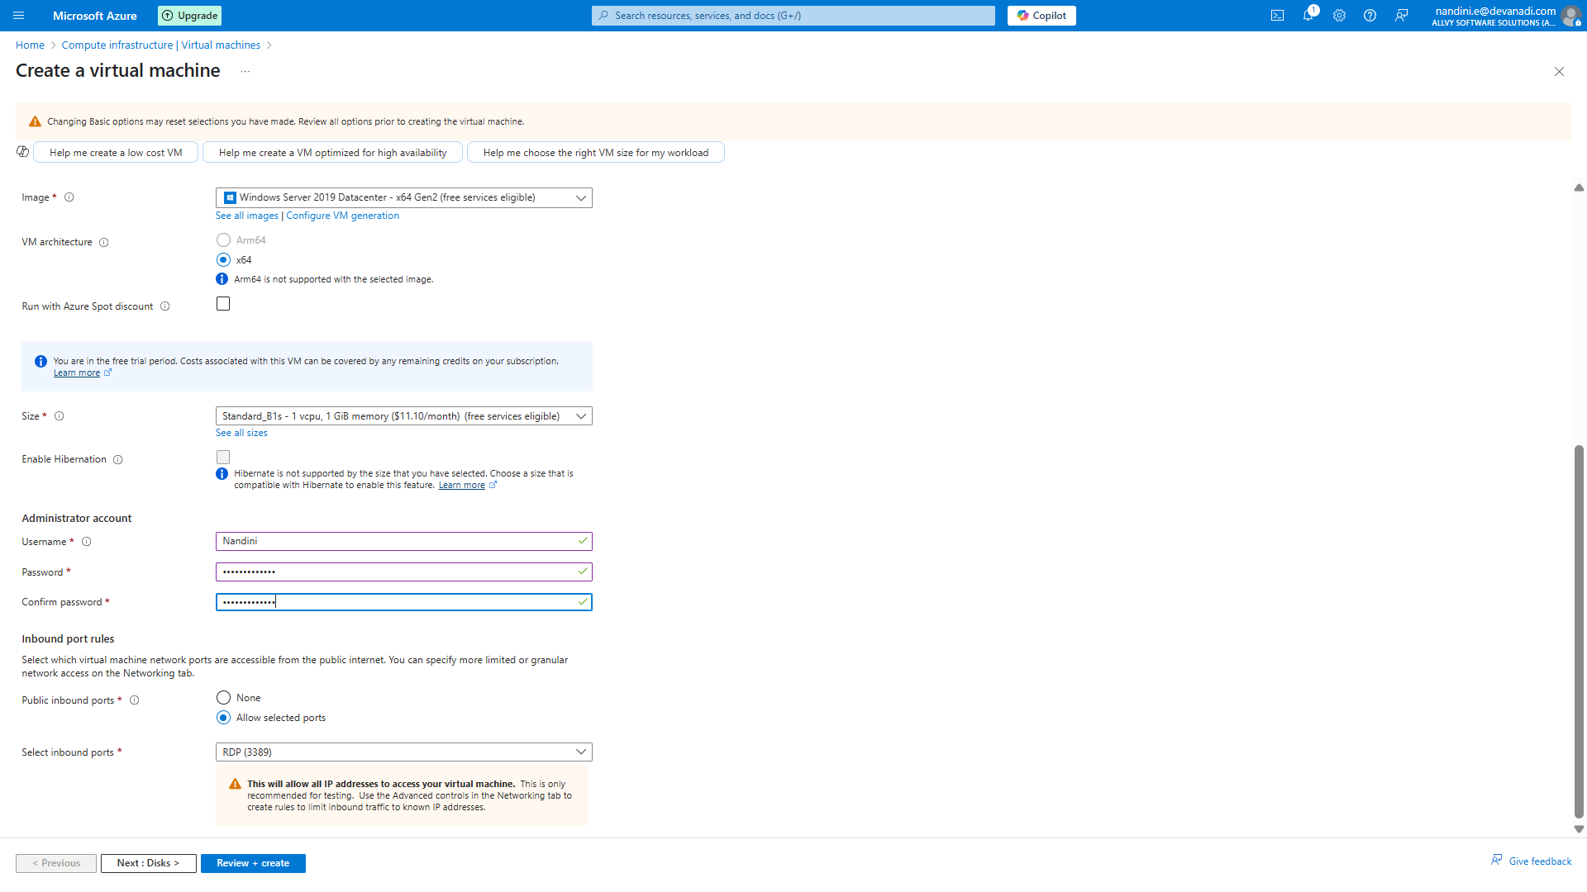

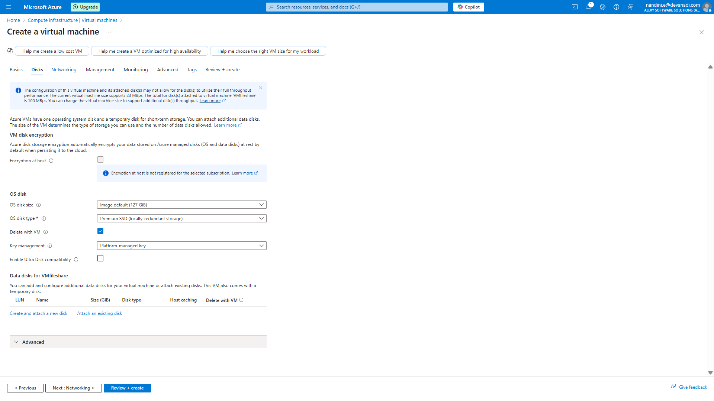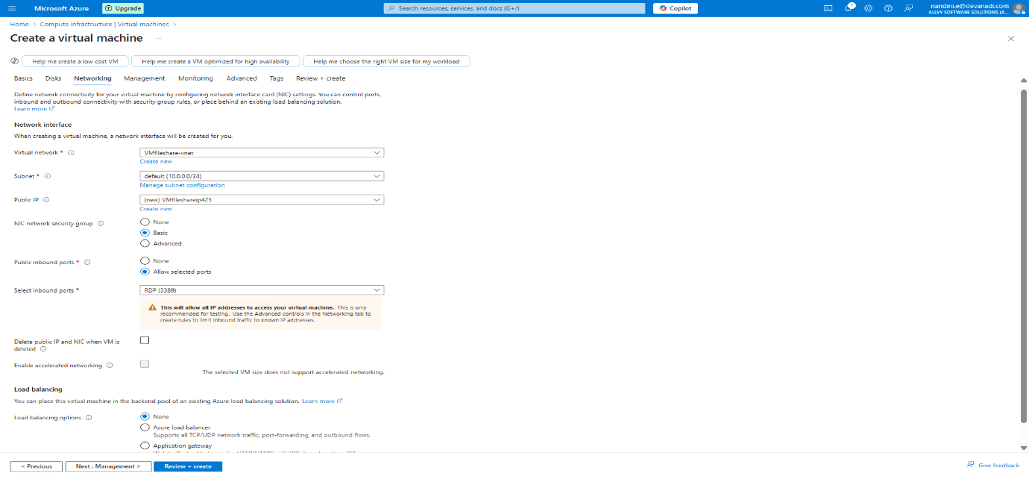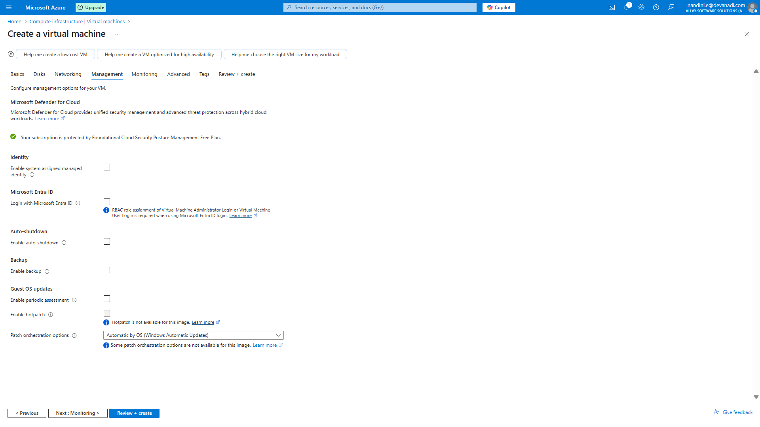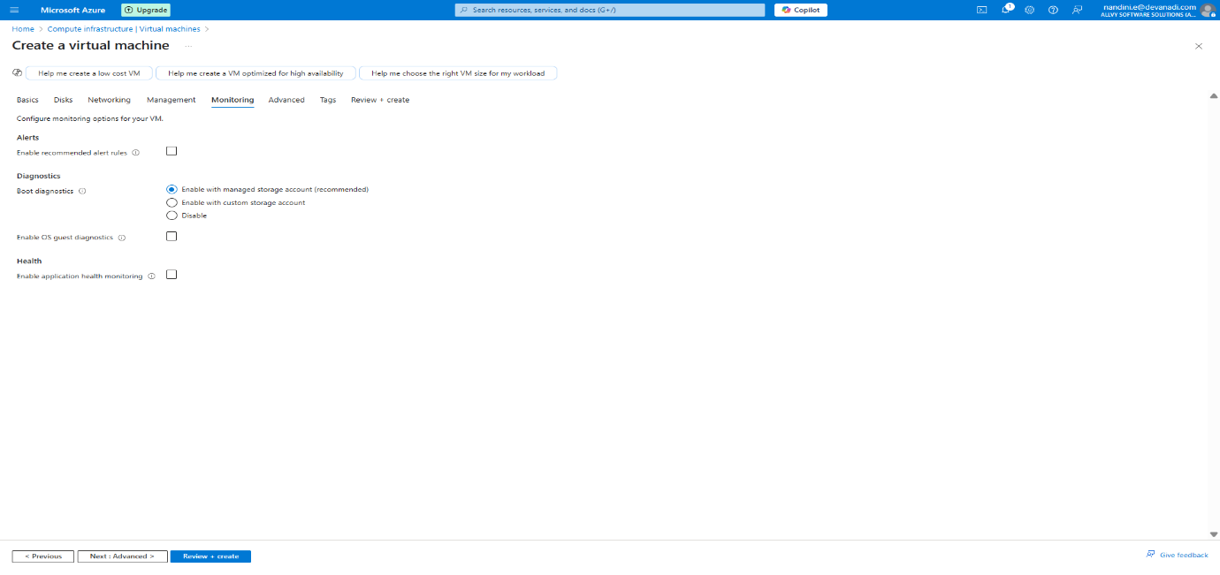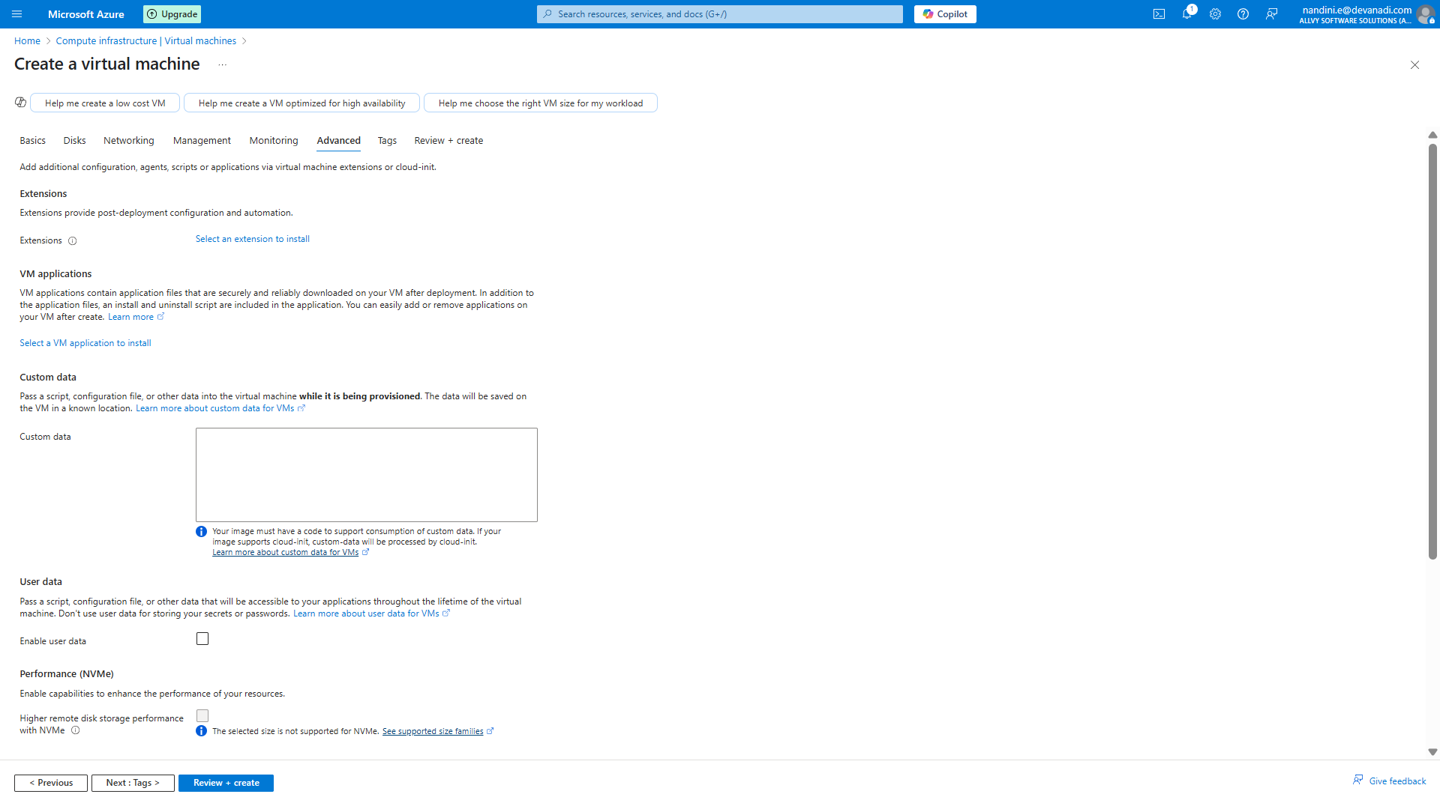

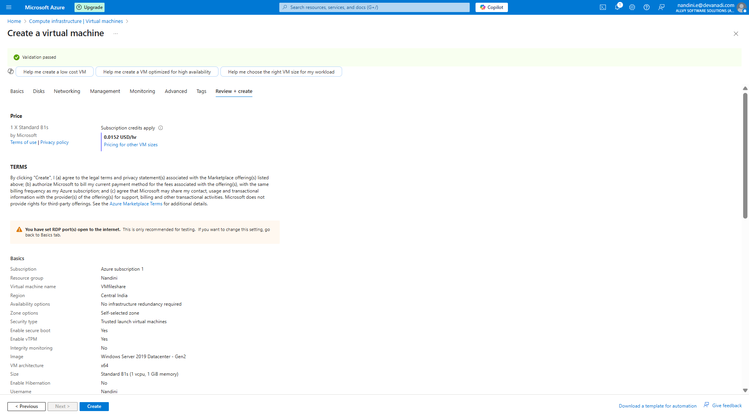

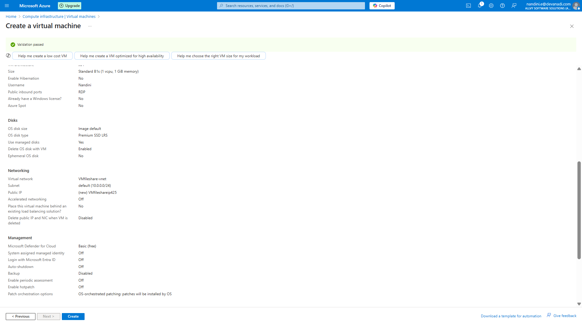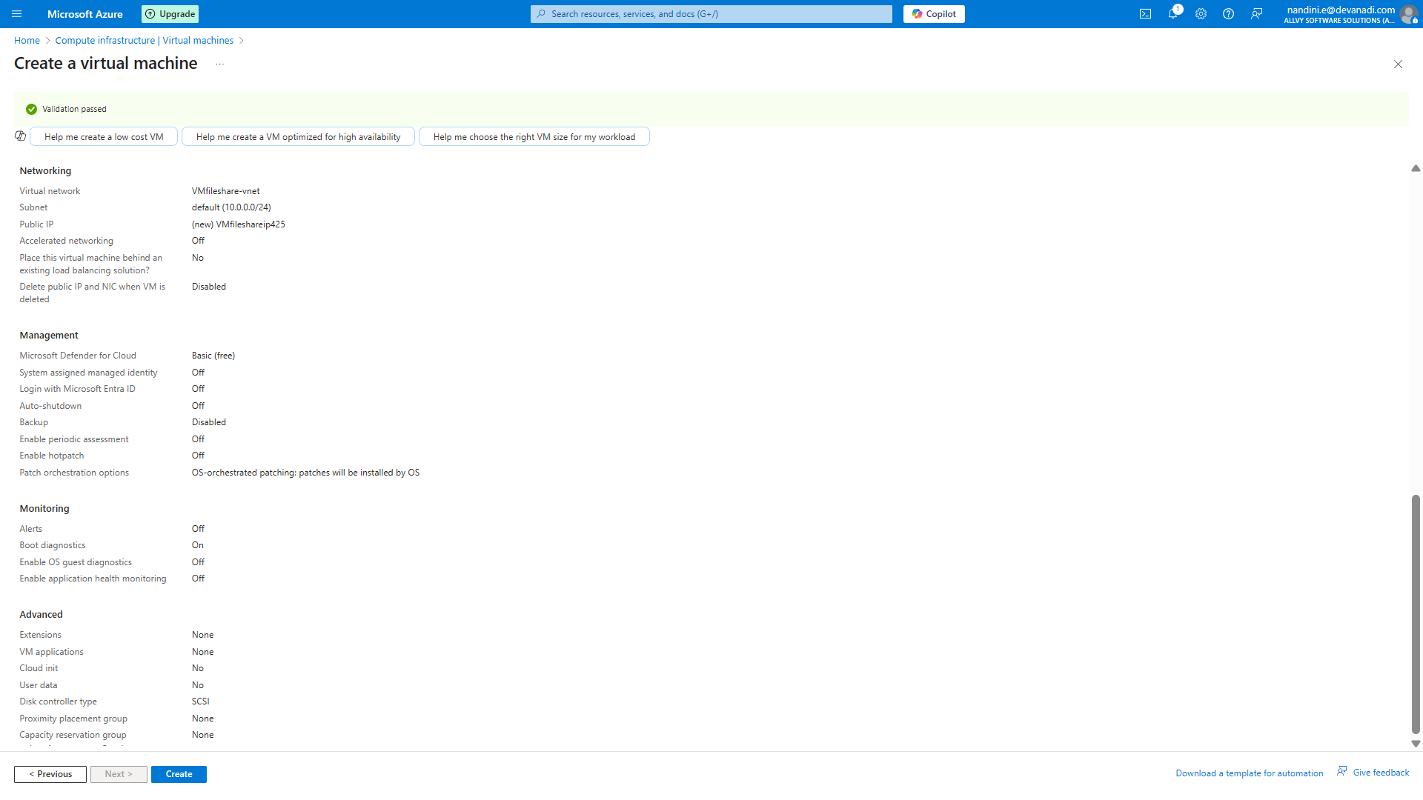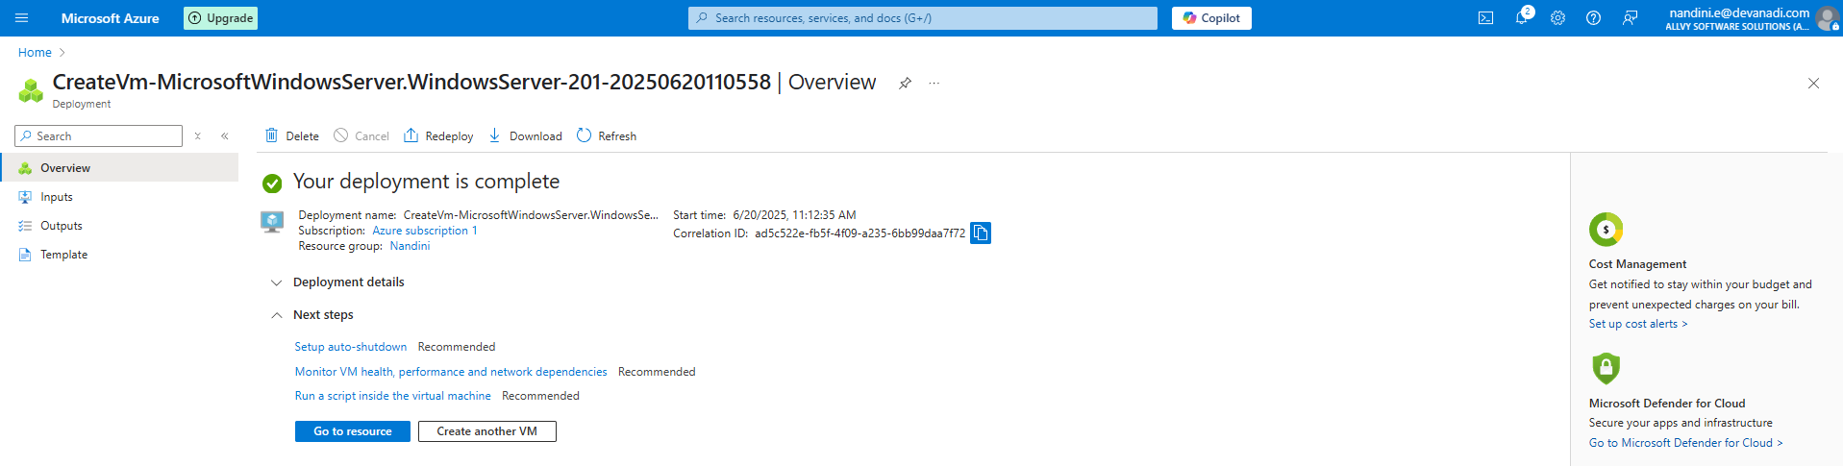

**Step2:** Create a Storage Account

Go to **Storage Accounts** -> **Create**

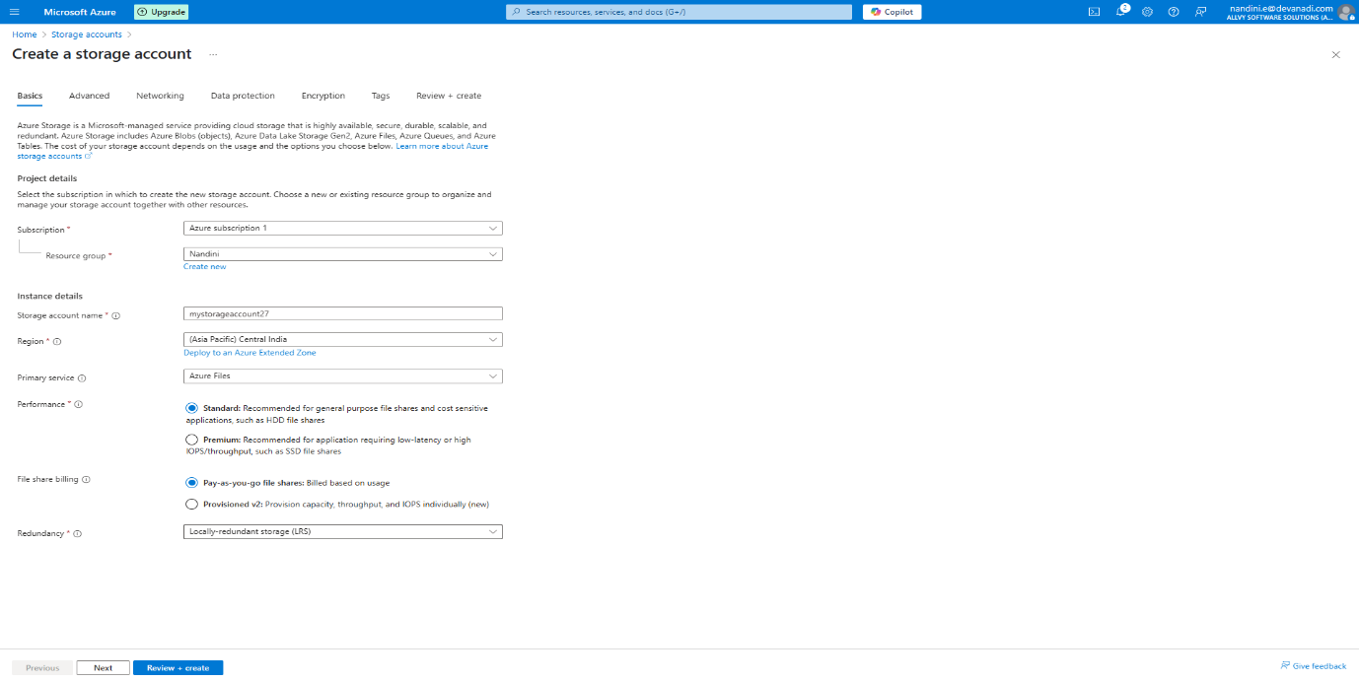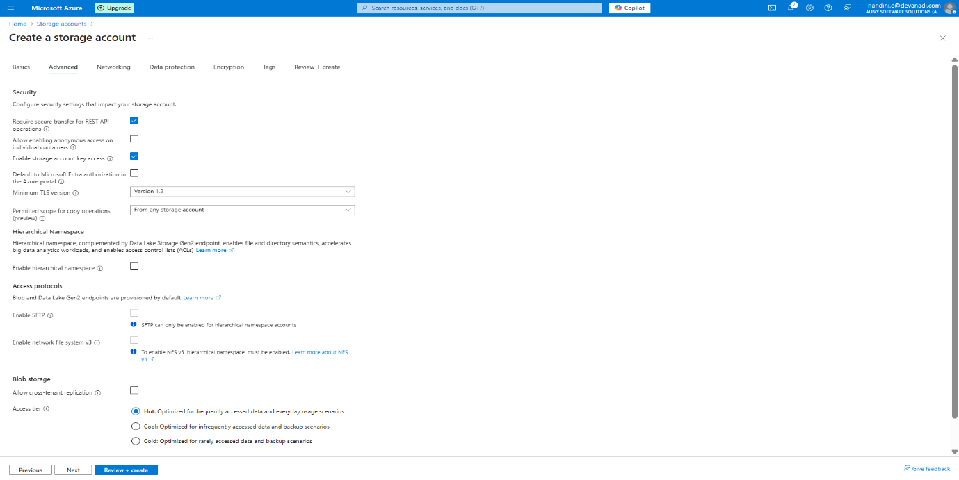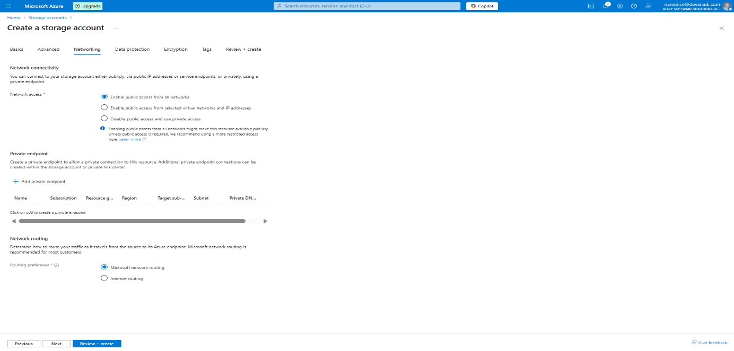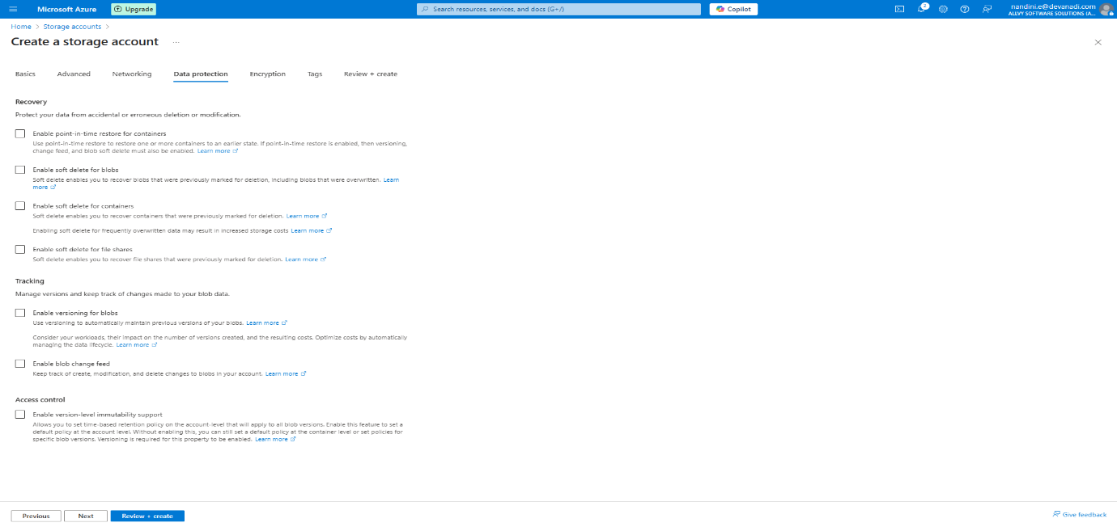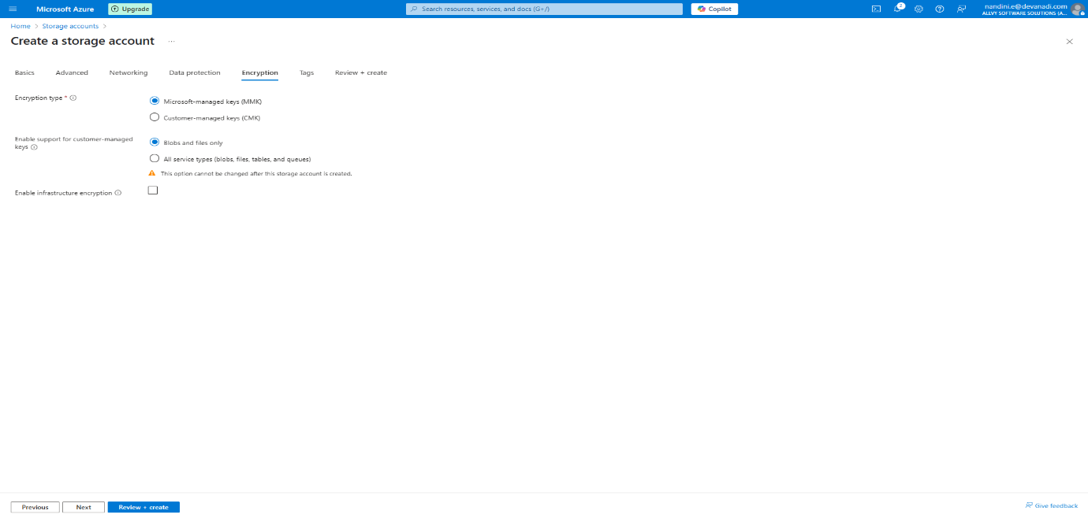

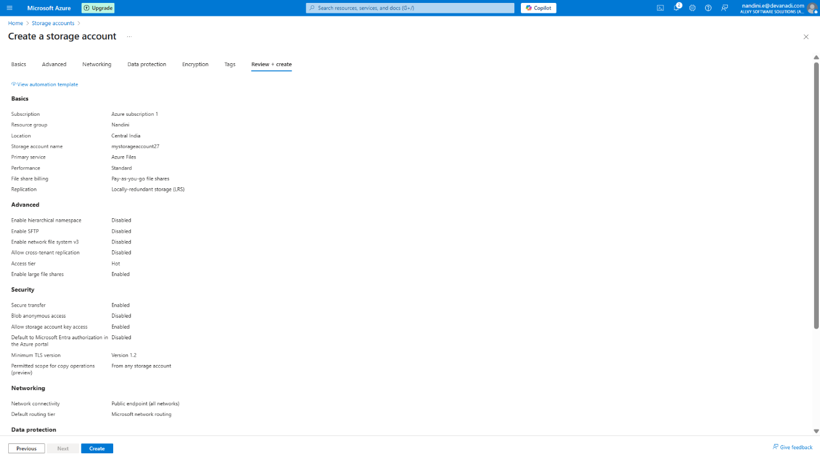

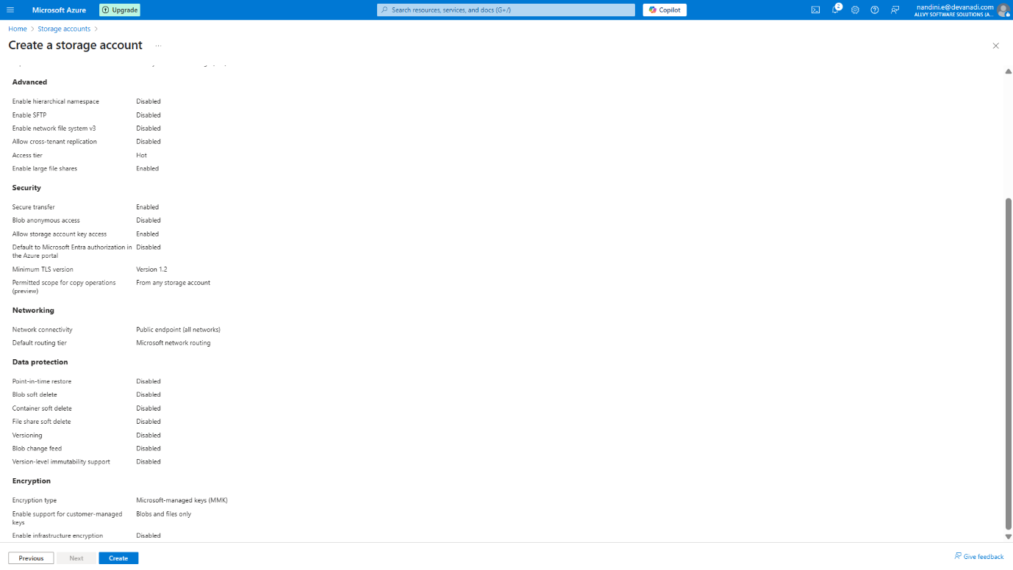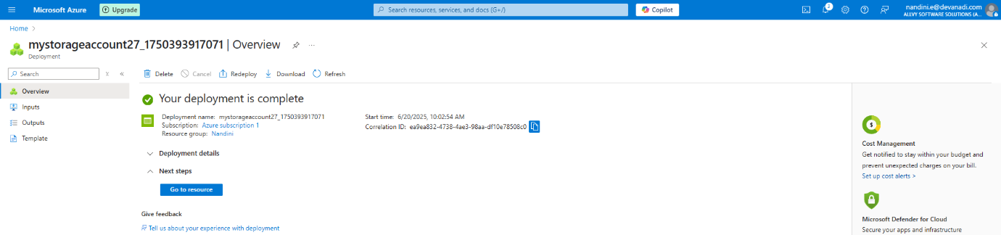

Once created, open the Storage Account

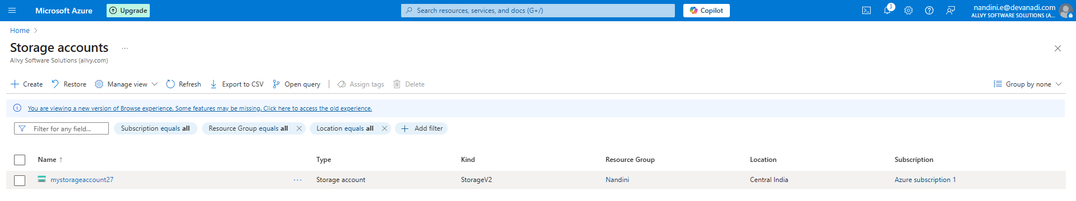

**Step 3:** Create a File Share

In the storage account, go to:

* **Data Storage** -> **File Shares**

Click on **+ File share**:

* **Name**: myfileshare
* Click **Create**

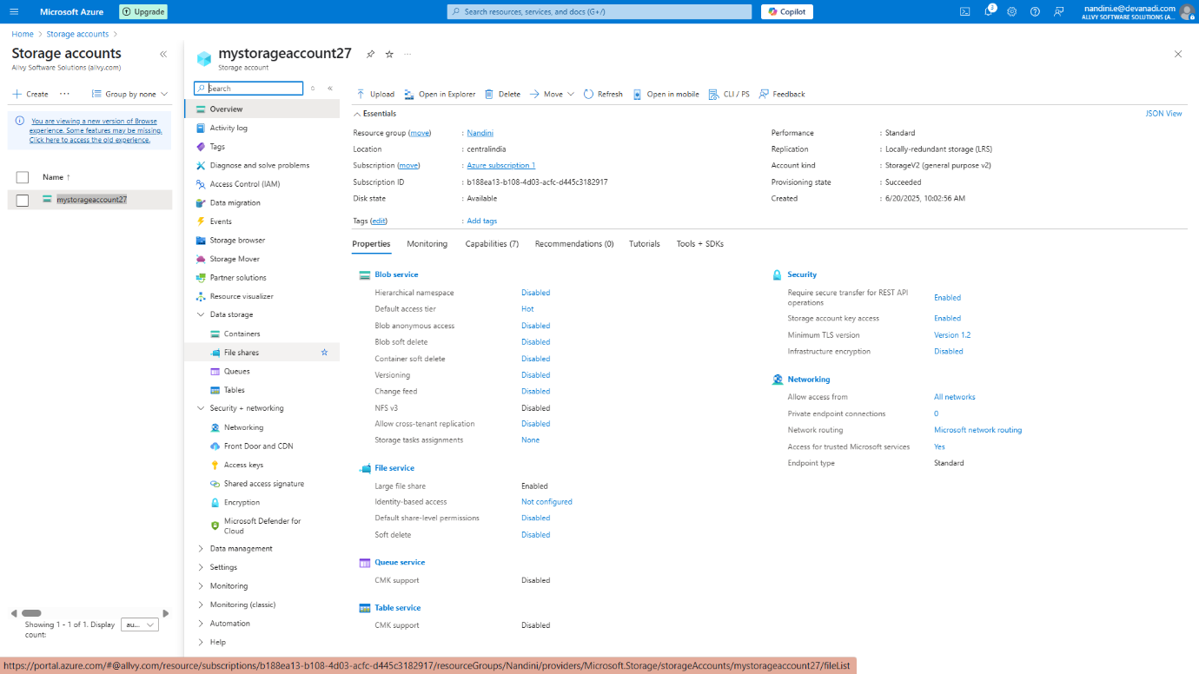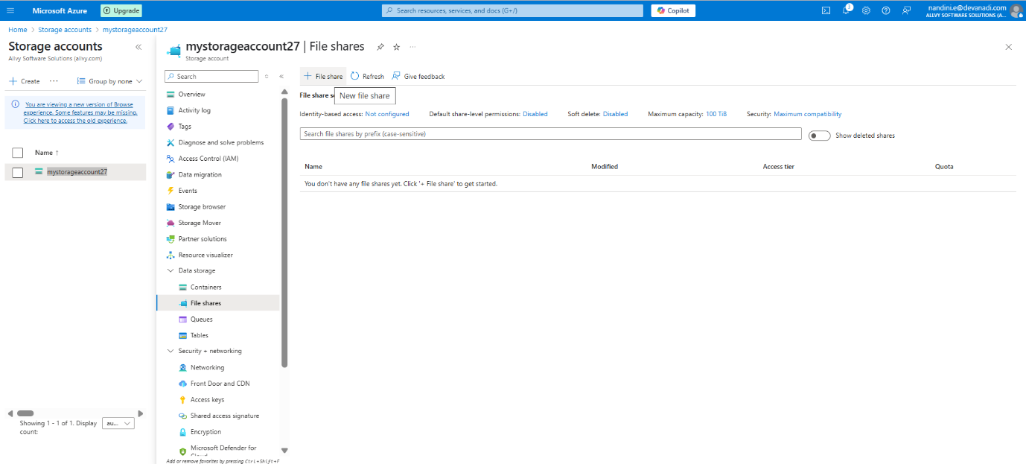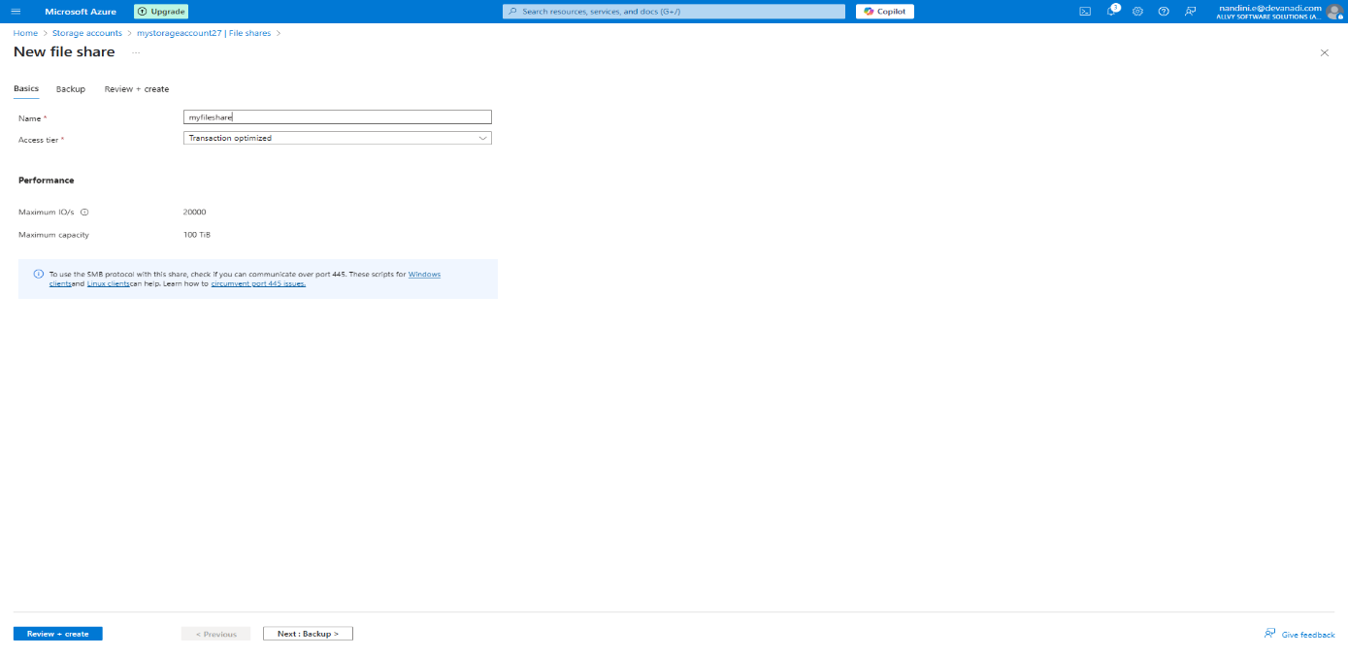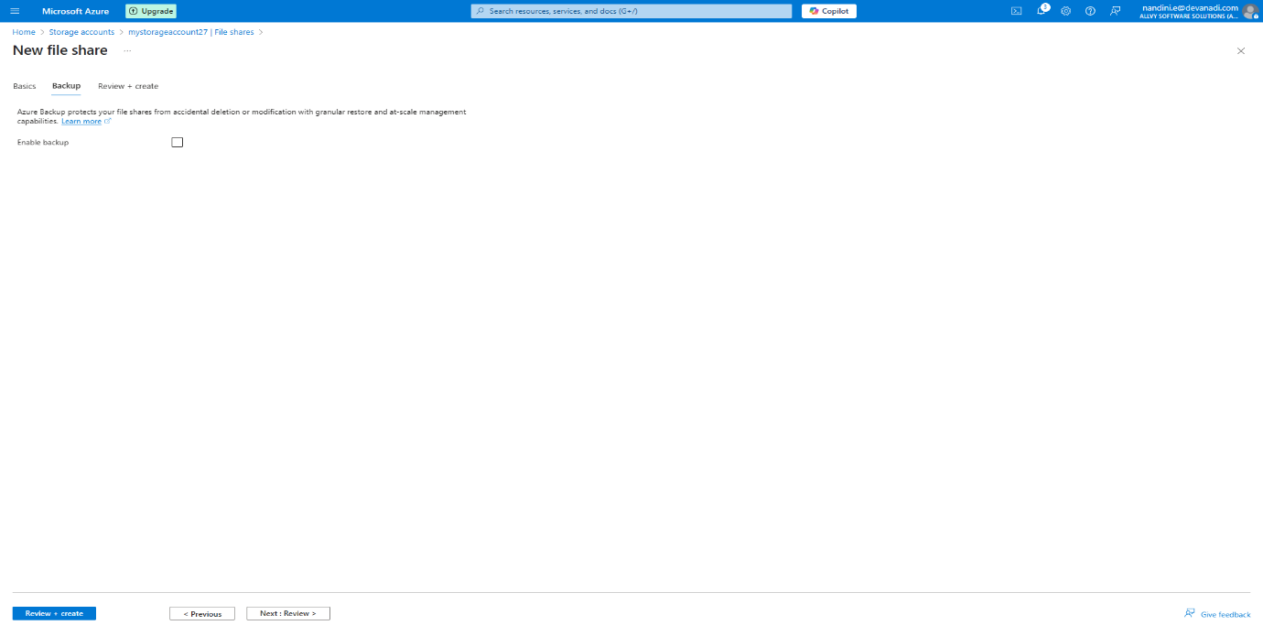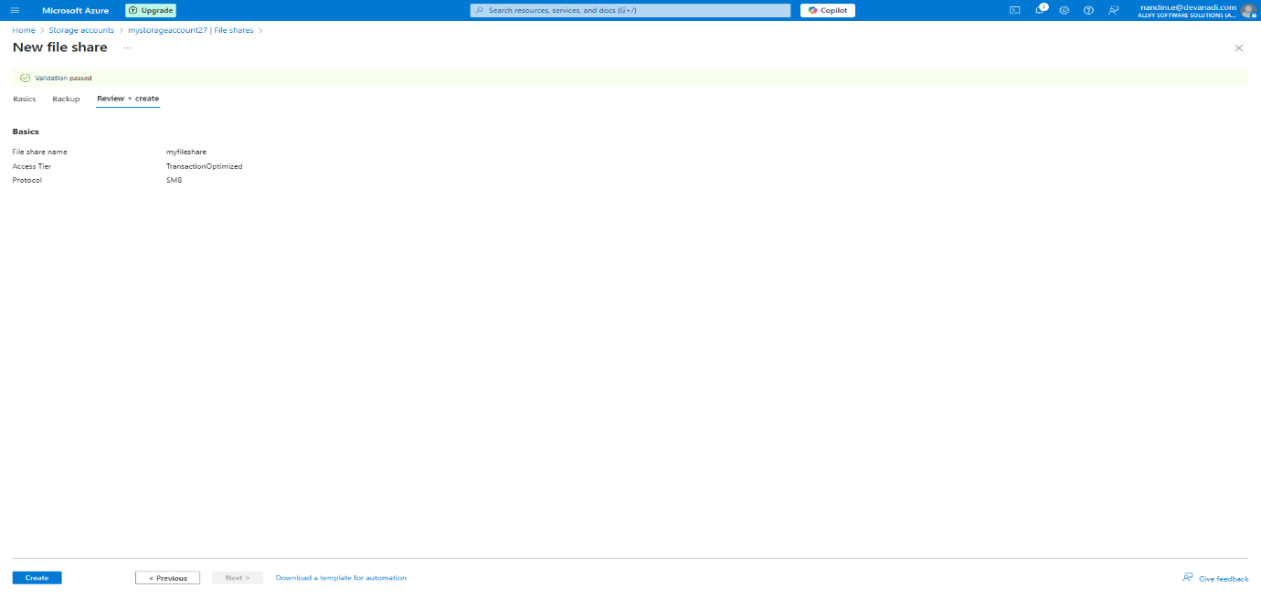

File share created successfully.

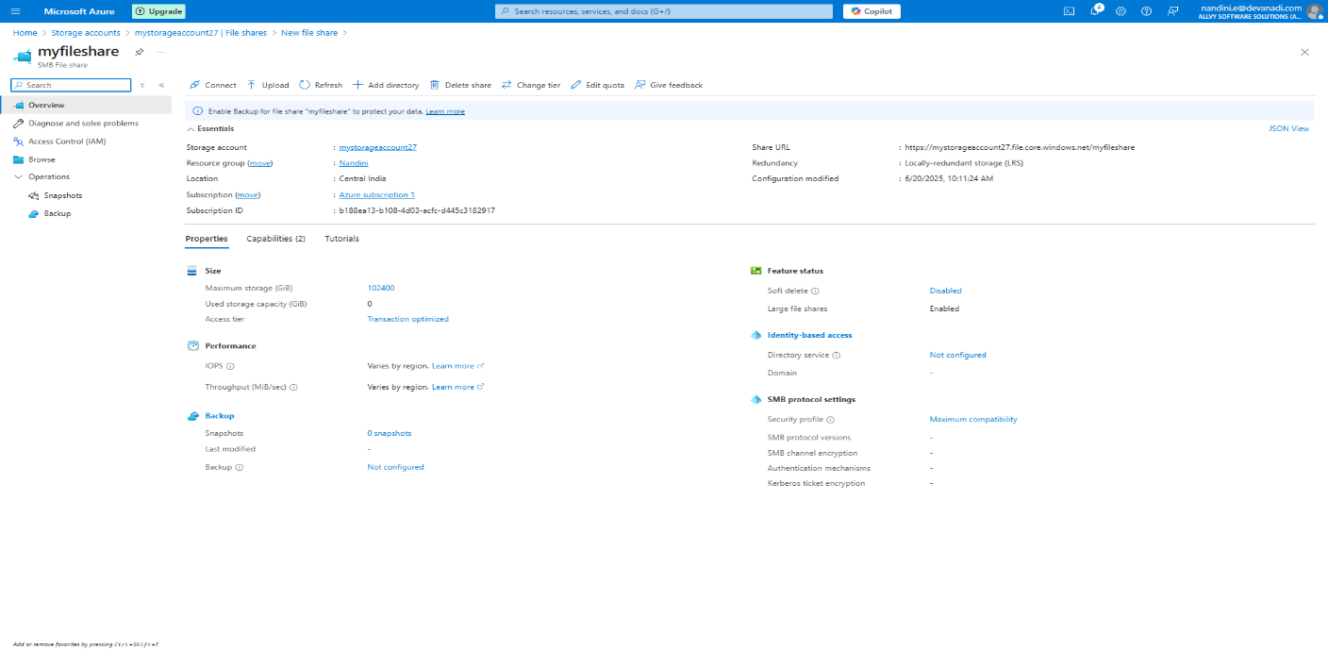

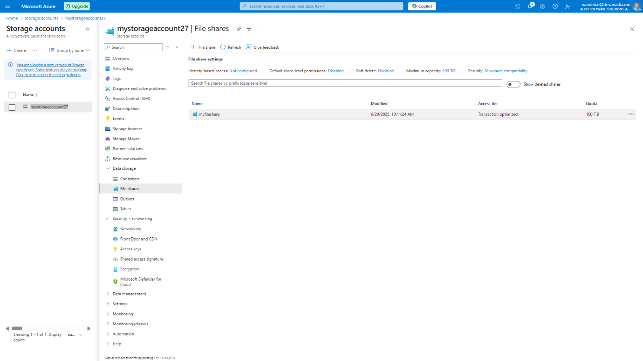

**Step 4:** Connect to the VM Using windows desktop connection

* Go to your VM resource in the Azure portal.
* Copy the **public IP address**.

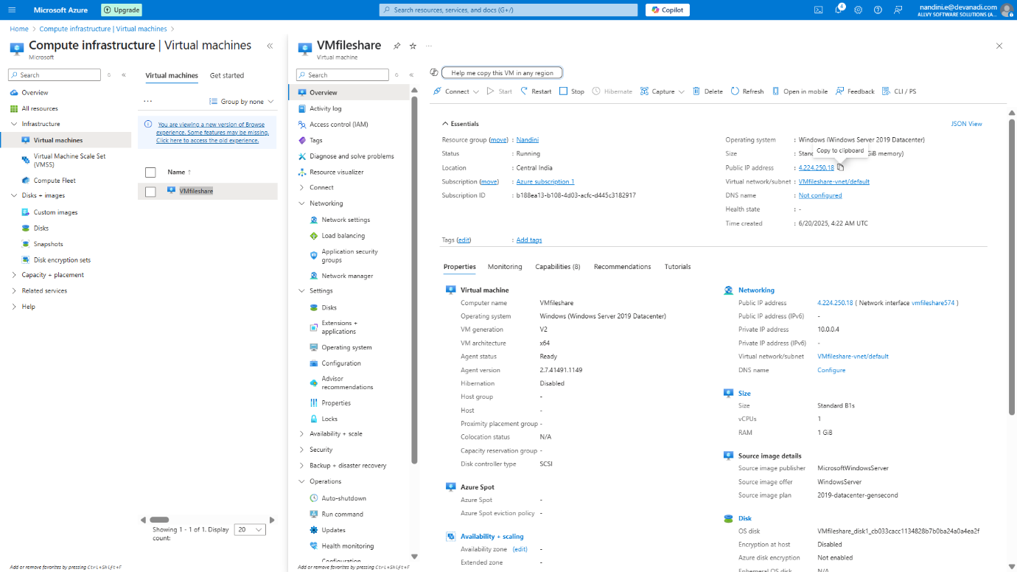

Open **Remote Desktop Connection** and:

* Open **Remote Desktop Connection (mstsc)** on your local system.
* Paste the IP address

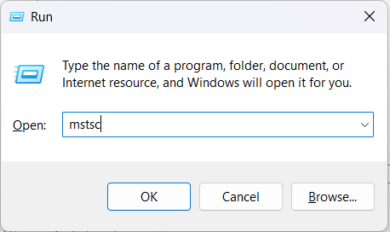

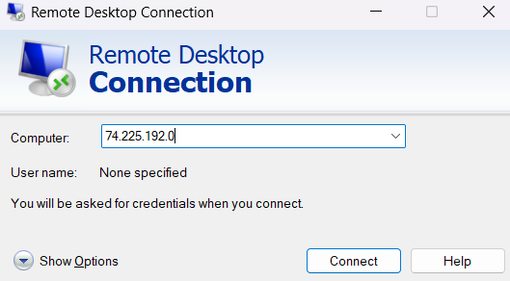

* Login with your **username** and **password**

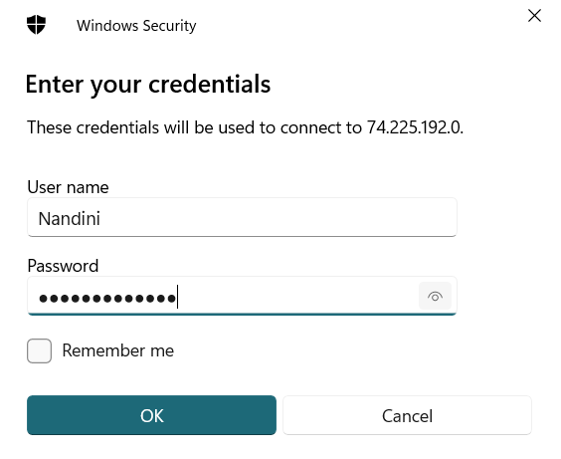

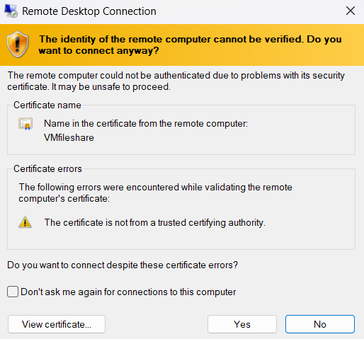

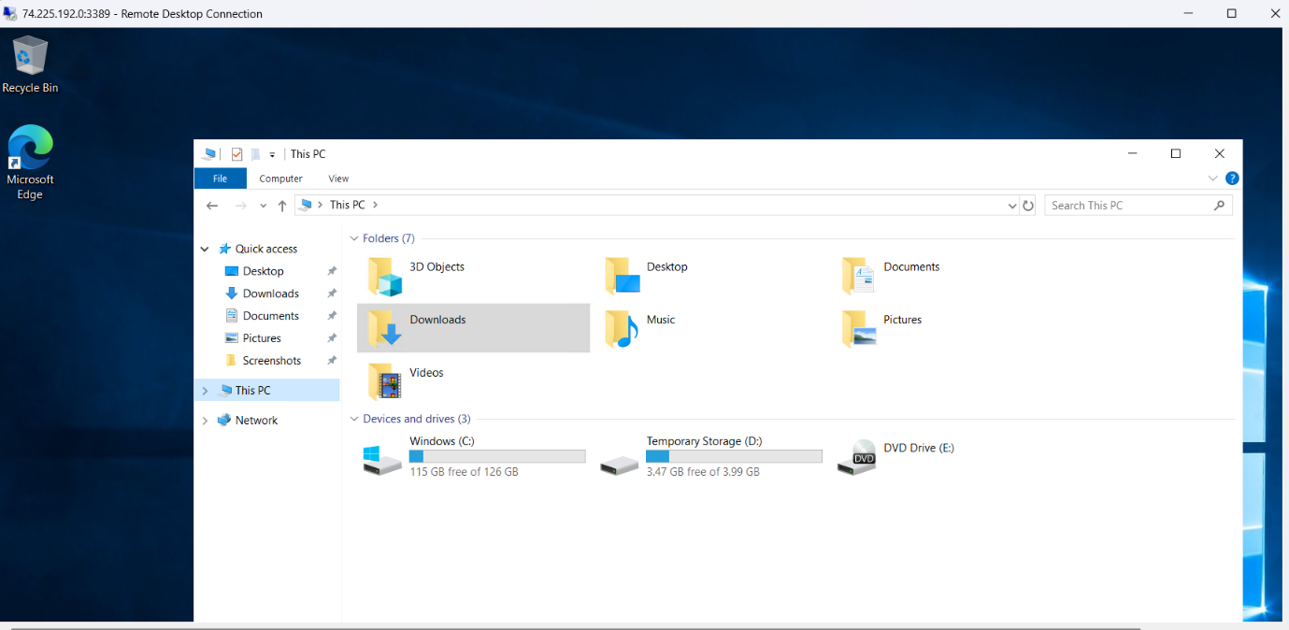

**Step 5: Retrieve File Share Mount Script**

Go back to the storage account.

* Navigate to **File Shares** -> myfileshare

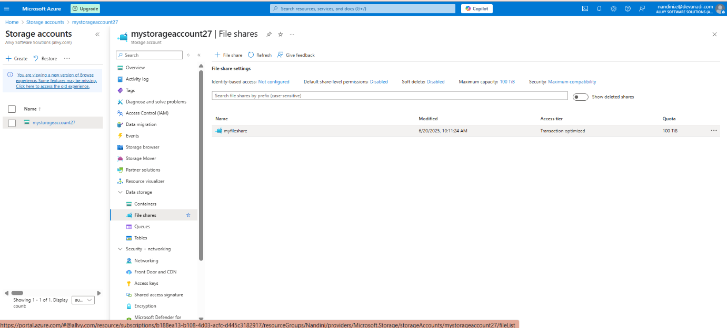

Click **Connect**

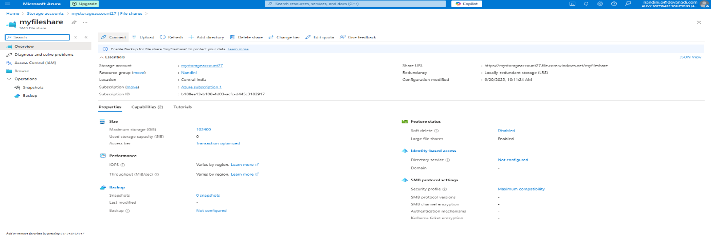

* Select Windows
* Copy the script provided by Azure (uses SMB and a mount command)

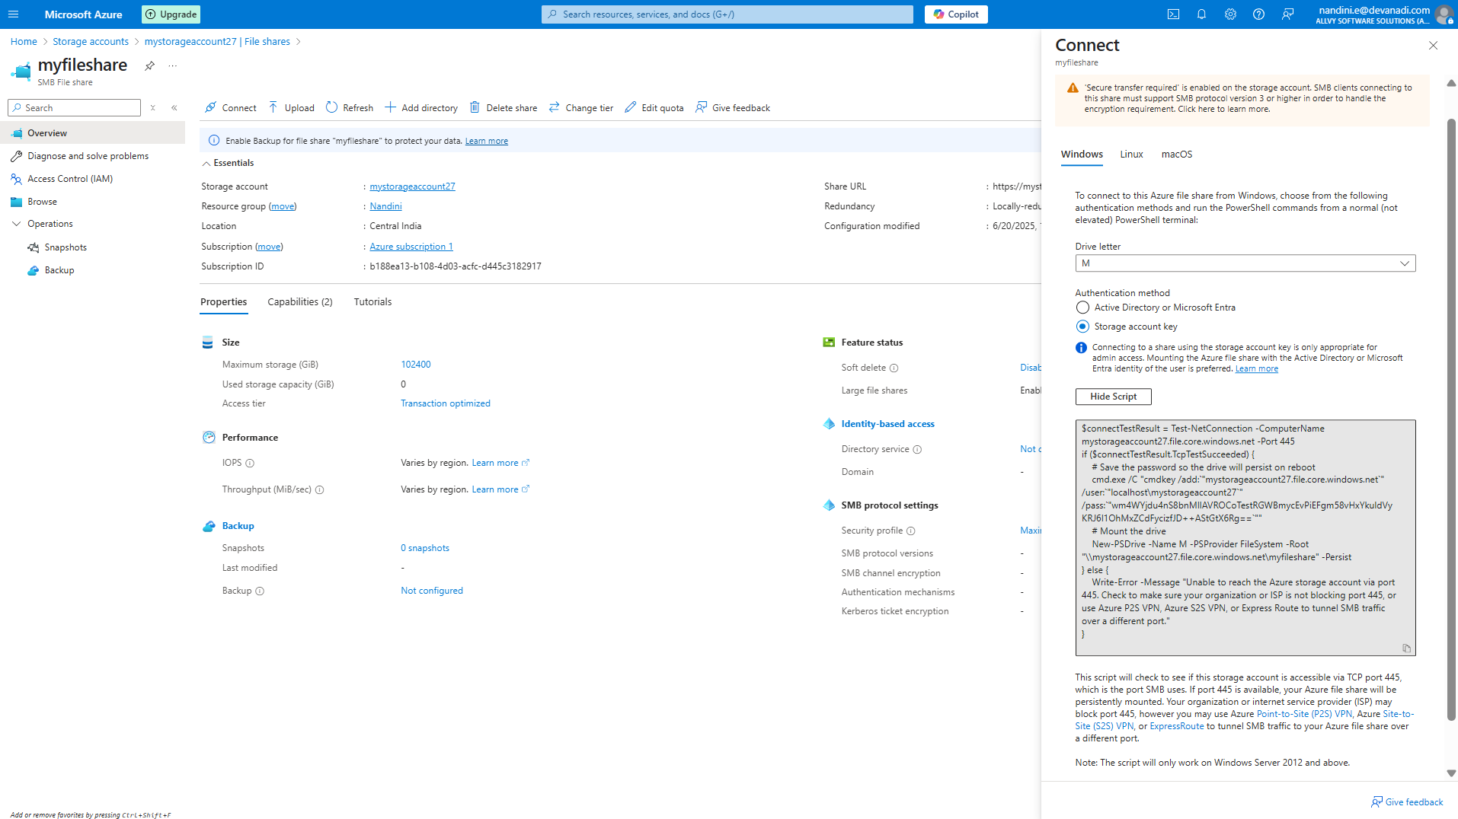

Check the script password and go access keys

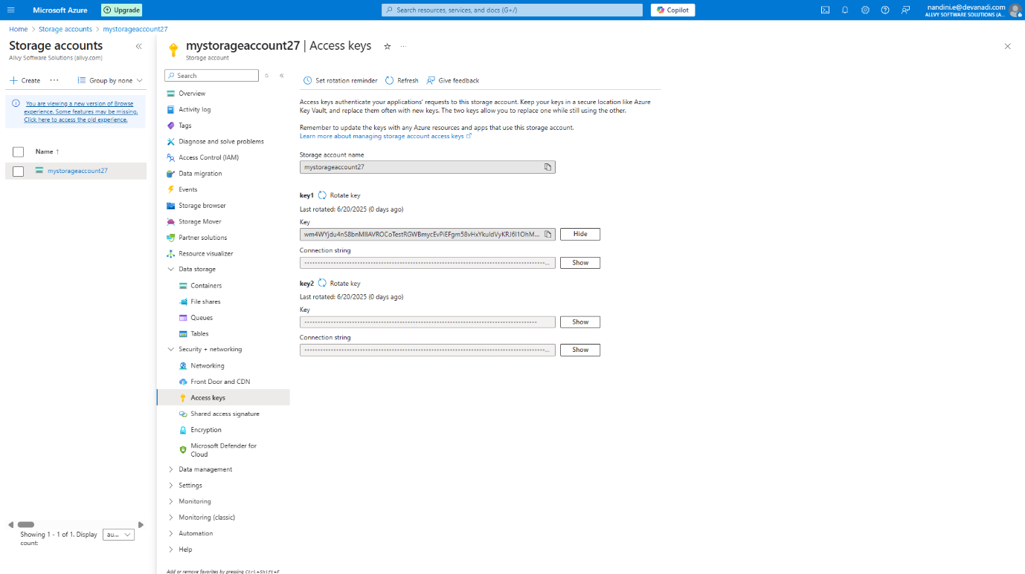

Ensure Access Key Matches the Script

**Step 6: Mount File Share on VM**

1. Open **PowerShell** as Administrator on the VM.
2. Paste and run the mount script you copied earlier.
3. The file share should now be mounted as a network drive (M).

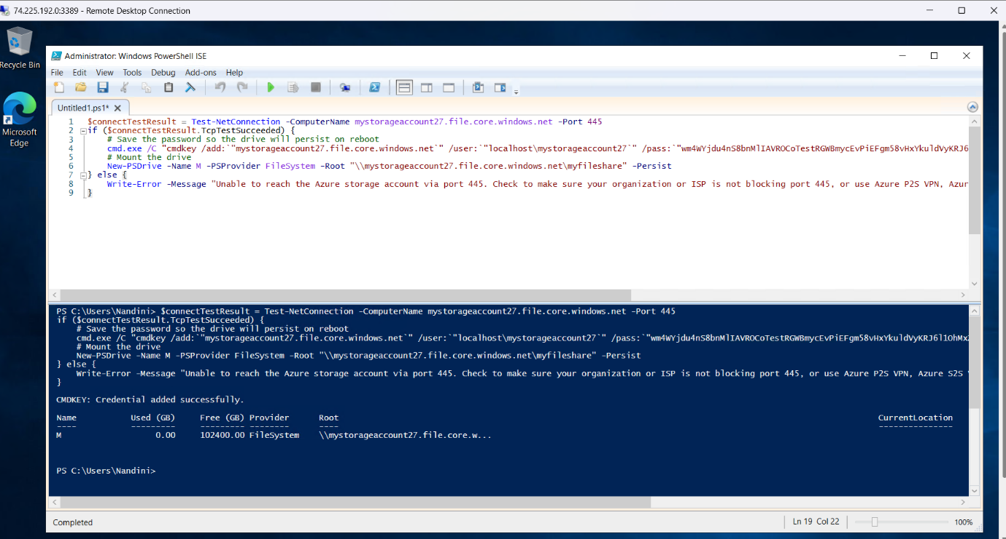

**Verification**

* Open **File Explorer** on the VM.
* Check under **This PC** → You should see the mounted drive (e.g., M:\myfileshare).
* You can now read/write files directly to Azure Storage via the mounted drive.

